H.T No
Regulations:
A18

Sreenidhi Institute of Science and Technology
(An Autonomous Institution)
Code No: 7EC01 Date: 17-August-2024 (FN)

B.Tech II-Year II- Semester External Examination, August - 2024 (Supplementary)
DATA STRUCTURES (ECE)

Time: 3 Hours Max.Marks:70

Note: a) No additional answer sheets will be provided.
b) All sub-parts of a question must be answered at one place only, otherwise it will not be valued.
c) Missing data can be assumed suitably.

Bloom's Cognitive Levels of Learning (BCLL)

Remember | L1 | Apply | L3 | Evaluate | L5
Understand | L2 | Analyze | L4 | Create | L6

Part - A Max.Marks:20
Answer all QUESTIONS

 |  | BCLL | CO(s) | Marks
1 | List out the applications of Queues | L1 | CO1 | [2M]
2 | Is linked list a linear data structure? Justify your answer with an example | L5 | CO2 | [2M]
3 | Differentiate between weighted and unweighted graphs. Give examples. | L4 | CO3 | [2M]
4 | What is Heap? | L1 | CO4 | [2M]
5 | What is data encapsulation? Give example? | L1 | CO5 | [2M]
6 | Explain Characteristics of Friend Function in C++. | L2 | CO6 | [2M]
7 | Illustrate stack operations PUSH and POP with suitable example. | L4 | CO1 | [2M]
8 | Write the preorder and postorder traversal for the following binary search tree.  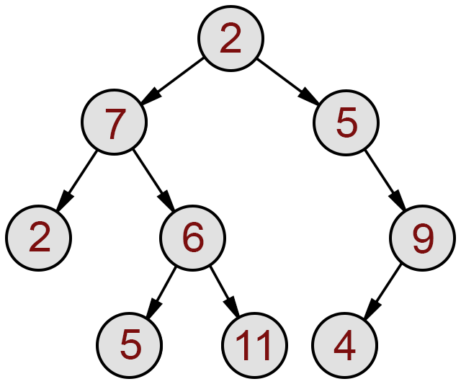 | L1 | CO3 | [2M]
9 | When do you call an object destructor? | L1 | CO5 | [2M]
10 | Write syntax for function template. | L1 | CO6 | [2M]
Part – B Max.Marks:50
ANSWER ANY FIVE QUESTIONS. EACH QUESTION CARRIES 10 MARKS.

 |  |  | BCLL | CO(s) | Marks
11. | a) | Illustrate the procedure for performing basic operations on a stack. | L4 | CO1 | [5M]
 | b) | Write a program using arrays to implement the queue operations. | L1 | CO1 | [5M]
12. | a) | Illustrate the operations of DLL with example. | L6 | CO2 | [5M]
 | b) | How to represent stack with linked list? Discuss. | L4 | CO2 | [5M]
13. | a) | What is height balanced binary search tree? Show each step in AVL tree while inserting the elements given 50,45,33,42,12,60,19,18,28,16. Start with an empty tree. Label the rotation according to type. | L1 | CO3 | [5M]
 | b) | Explain BFS traversal algorithm with Example. | L2 | CO3 | [5M]
14. | a) | Explain Heap sort for the following List of elements to sort in Descending order 16, 14, 10, 8, 7, 9, 3, 2, 4, 1 | L5 | CO4 | [5M]
 | b) | Write down the merge sort algorithm and give its worst case, best case and average case analysis. | L4 | CO4 | [5M]
15. | a) | Explain all types of constructors in C++ with examples. | L2 | CO5 | [5M]
 | b) | Write a C++ Program to print Fibonacci series of n terms. | L1 | CO5 | [5M]
16. | a) | Write a program to overload unary operator with friend function. | L3 | CO6 | [5M]
 | b) | How can we achieve dynamic memory management with operators new and delete? | L2 | CO6 | [5M]
17. | a) | Write an Example of Infix to Postfix Conversion. | L1 | CO1 | [4M]
 | b) | Write any two functions on stack using Linked list. | L1 | CO2 | [3M]
 | c) | Explain Graph Representation with Example. | L2 | CO3 | [3M]
18. | a) | Sort the following array using insertion sort  25,30,66,99,54,28,13,58 | L4 | CO4 | [4M]
 | b) | What is copy constructor? Give an suitable example. | L1 | CO5 | [3M]
 | c) | What do you mean by function overloading? | L1 | CO6 | [3M]
-- 00 -- 00 –

